**ADVANCE DEVOPS EXPERIMENT 4**

Prajjwal Pandey – D15A/33

**Aim:**To install Kubectl and execute Kubectl commands to manage the Kubernetes cluster and deploy Your First Kubernetes Application.

1. **Install prerequisites:** sudo apt-get update sudo apt-get install -y apt-transport-https ca-certificates curl

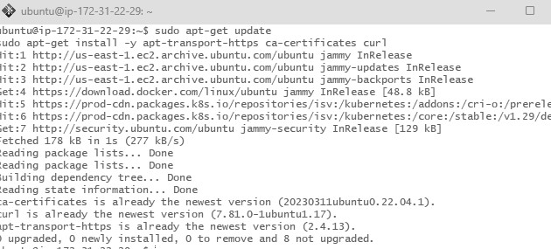

1. **Add the GPG key for Kubernetes:**

sudo curl -fsSLo /usr/share/keyrings/kubernetes-archive-keyring.gpg

<https://packages.cloud.google.com/apt/doc/apt-key.gpg>

1. **Add the Kubernetes repository:**

echo "deb [signed-by=/usr/share/keyrings/kubernetes-archive-keyring.gpg]

https://apt.kubernetes.io/ kubernetes-focal main" | sudo tee

/etc/apt/sources.list.d/kubernetes.list

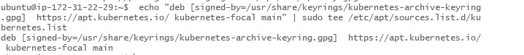

**1.2 Install kubectl** sudo apt-get update

sudo

apt-get

install

-

y

kubectl

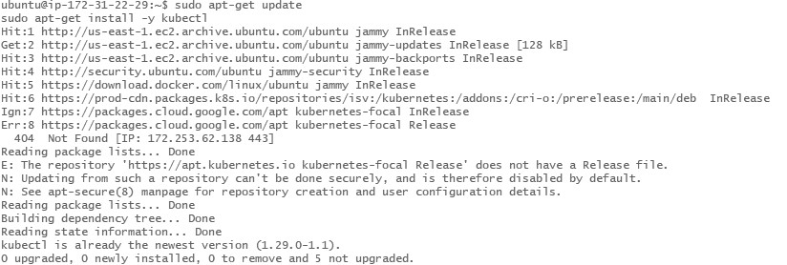

**Step 2: Deploying Your Application on Kubernetes**

# 2.1 Set up Kubernetes Cluster

kubectl get nodes

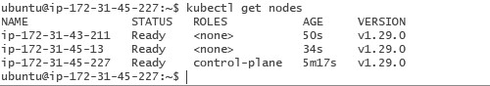

# Step 3:Create the Deployment YAML file

a)Create the YAML file: Use a text editor to create a file named nginx-deployment.yaml

b) Add the Deployment Configuration: Copy and paste the following YAML content into the file. Save and exit the editor (Press Ctrl+X, then Y, and Enter).

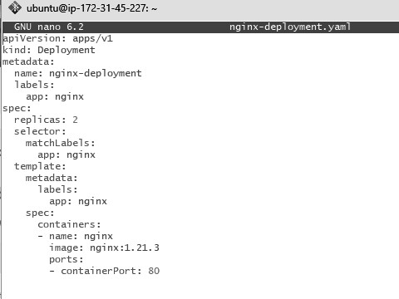

# Step 4:Create the Service YAML File

a)Create the YAML File: Create another file named nginx-service.yaml



b)Add the Service Configuration: Copy and paste the following YAML content into the file given below.

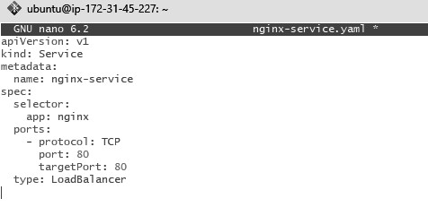

# Step 5:Apply the YAML Files

a)Deploy the Application: Use kubectl to create the Deployment and Service from the YAML files.



b)Verify the Deployment: Check the status of your Deployment,Pods and Services.

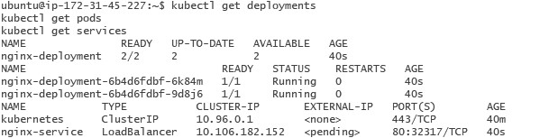

Describe the deployment(Extra)

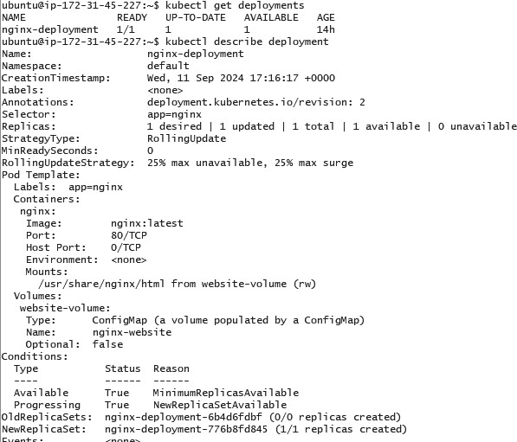

# Step 6:Ensure Service is Running

kubectl

get

service

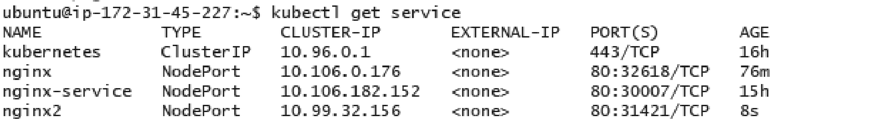

# Step 7:Forward the Service Port to Your Local Machine

kubectl port-forward allows you to forward a port from your local machine to a port on a service running in the Kubernetes cluster.

1. **Forward the Service Port**: Use the following command to forward a local port to the service's target port. kubectl port-forward service/<service-name> <local-port>:<service-port>



This command will forward local port 8080 on your machine to port 80 of the service nginx-service running inside the cluster.

1. This means port forwarding is now active, and any traffic to localhost:8080 will be routed to the nginx-service on port 80.

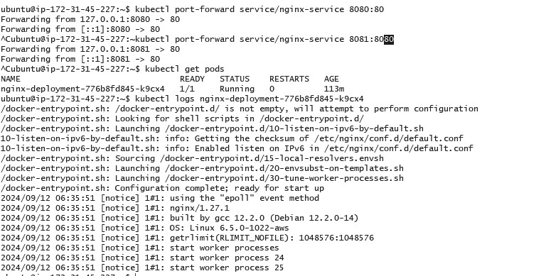

# Step 8: Access the Application Locally

1. **Open a Web Browser**: Now open your web browser and go to the following URL:

http://localhost:8080

You should see the application (in this case, Nginx) that you have deployed running in the Kubernetes cluster, served locally via port 8080.

In case the port 8080 is unavailable, try using a different port like 8081

